**Lab 2 – Attributes/CSS**

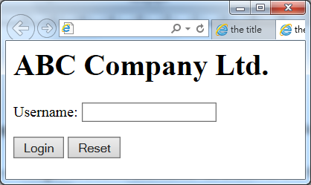**Lab 2-1**

Write a jQuery program to input the username and then do the followings when the Login button is clicked.

1. Display the message “Welcome *username*” below the button “Login”.
2. A dialogue box is displayed with the message “You have logged in successfully, *username*”

The inputbox is cleared when the Reset button is clicked.

**Lab 2-2**

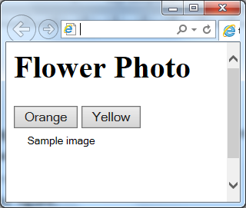

Write a jQuery program for the user to choose which image should be displayed in the browser.

**Lab 2-3**

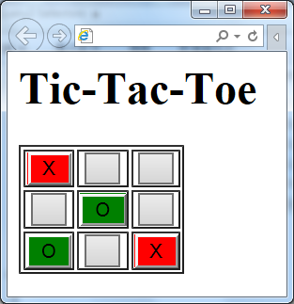Write a program to show the Tic-Tac-Toe in table

format as shown in the figure. Each cell of the table

contains a button.

When a button is clicked, the background color is changed

to red and a black cross(“X”) is displayed.

When a button is double clicked, the background color is

changed to green and a black circle(“O”) is displayed.

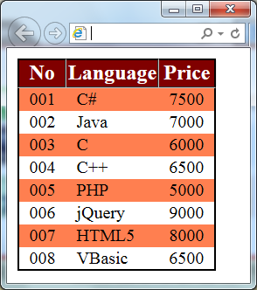**Lab 2-4**

Write a jQuery program to display the table as shown in the figure.

For row No: 001, 003, 005 and 007, the class *tr.striped* is applied.

When the mouse is over a row, the class *tr.over* is applied. When the mouse leaves the row, the class is removed.

Given the style of the program:

<style type="text/css">

body, td { font-size: 10pt; }

table { background-color: black; border: 1px black solid; border-collapse: collapse; }

th { border: 1px outset silver; background-color: maroon; color: white; }

tr { background-color: white; margin: 1px; }

tr.striped { background-color: coral; }

tr.over { background-color: gold; }

td { padding: 1px 8px; }

</style>

Given the first 2 rows of the table:

<table>

<tr><th>No</th><th>Language</th><th>Price</th></tr>

<tr><td>001</td><td>C#</td><td>7500</td></tr>

………

</table>

**Lab 2-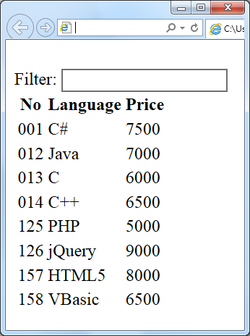5**

Write a jQuery program to filter out the irrelevant items from the list as shown in the figure.

When a user keys in a phrase in the textbox, only the row(s) with content matched with the phrase will be displayed.

[ Use **filter** and **contains** ]

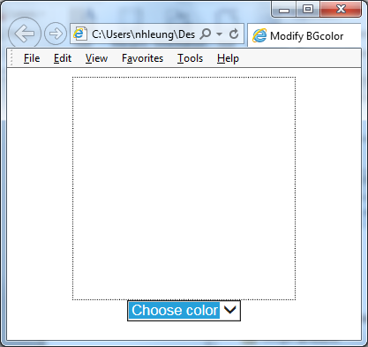**Lab 2-6**

Write a jQuery program to display a large square as displayed in the figure. User may choose a color from the dropdown box. When a color is chosen, the square changes to that color.

Given the body below:

<body>

<center>

<div id="div1" style="width:200px;height:200px;border:black 1px dotted">

</div>

<select id="color">

<option value="white">Choose color</option>

<option value="black">black</option>

<option value="gray">gray</option>

<option value="orange">orange</option>

<option value="yellow">yellow</option>

<option value="red">red</option>

</select><br />

</center>

</body>